Test
Name_____________________ _ ______2. Class___ №

1.Listen and tick().



7
17
Aa
Ee


4 points
2. Match.

three 4 5 seventeen
nine 20 8 eleven
four 3 17 twelve
five 12 13 twenty
eight 9 11 thirteen

10 points
3. Write. What’s this?

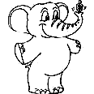
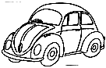
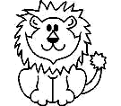
apple
car
lion
fish
cat
elephant
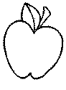
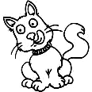
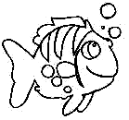

_______ _____ ______ ______ _______ ________
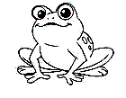
6 points 4. Colour.

a red apple
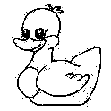
a yellow duck

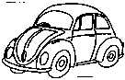
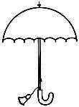
a blue car

a green frog

an orange umbrella

5 points

5.Write
is
are
am

My name ____Mark.
I____ten.
These _____Carol and Amy.
They _____ my friends. 4 points

6. Find five words.
w | d | f | p | b | a | e
o | d | a | d | r | x | s
m | u | m | v | o | l | j
i | s | i | s | t | e | r
g | x | l | v | h | c | u
o | q | y | h | e | o | m
n | w | e | y | r | s | y
family
mum
dad
sister
brother

5 points

7. Match and write.
in
behind
on
under
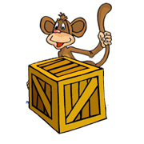
There’s a monkey
________the box.
There’s a monkey
_______the box.
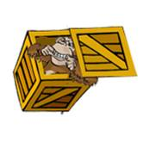
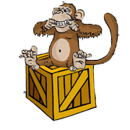
There’s a monkey
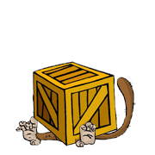
_______the box.

There’s a monkey
_______ the box.

4 points
8. Draw.
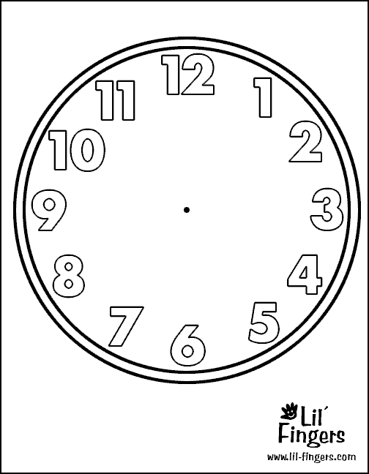

It’s eight o’clock. It’s eleven o’clock. 2 points

Total points 40

